Itay Ostraich 316397249

Yarin Manoah 208945956

**Database Project**

A general description of the original (java) program and what it does

This system manages the data of all the Exams Created in java.

Requirements for the system – what is the database for:

The purpose of the database:

1. To sort and manage all the data in an easy and convenient way
2. Get information about the types of Questions, on what are the answers for a proper check, or let the Teacher build an exam from a bank of a variety of questions.

Who are the users of the system?

The database is for:

1. Every university or college.

2. Teacher and Lecturers

3. Students

Describe the entities in the database (at least 5 entities) and the relationships between them. You may need to add functionality to the program.

**Entities:**

1. Question.
2. Answer.
3. Open Question.
4. MultiChoice Question.
5. MultiChoice answers.

**Relationships:**

*For Question:*

* *one Open Question is in one* Question.
* *one MultiChoice Question is in one* Question.

*For Open Question:*

* *one Open Question as one answer*.

*For MultiChoice Question:*

* *one MultiChoice Question as many MultiChoice answers.*

*For* *Answer*:

* *Many MultiChoice answers run in one answer.*

ERD diagram:

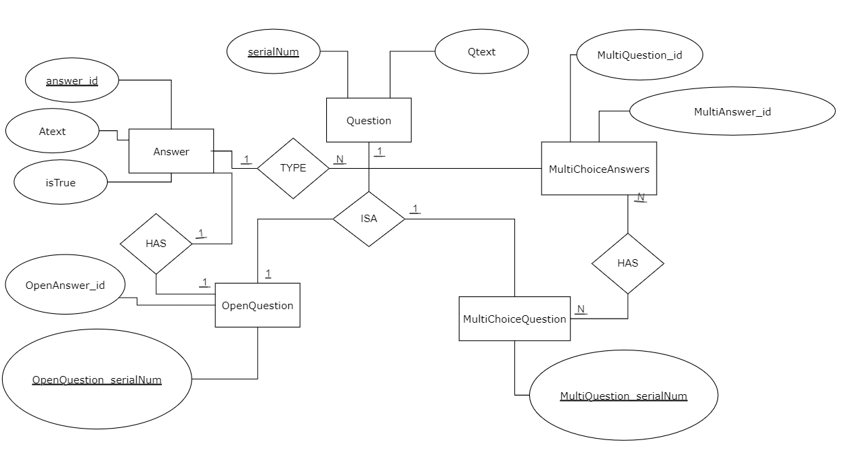

Define all the tables based on the ERD:

**Question**

|  |  |
| --- | --- |
| serialNum | Qtext |
|  |  |
|  |  |
|  |  |

**Answer**

|  |  |  |
| --- | --- | --- |
| answer_id | Atext | isTrue |
|  |  |  |
|  |  |  |

**OpenQuestion**

|  |  |
| --- | --- |
| OpenQuestion_serialNum* | OpenAnswer_id** |
|  |  |
|  |  |
|  |  |

*\* references Question’s serialNum*

*\*\* references Answer’s answer_id*

**MultiChoiceQuestion**

|  |
| --- |
| MultiQuestion_serialNum* |
|  |
|  |
|  |

*\* references Question’s serialNum*

**MultiChoiceAnswers**

|  |  |
| --- | --- |
| MultiQuestion_id* | MultiAnswer_id** |
|  |  |
|  |  |

*\* references MultiChoiceQuestion’s MultiQuestion_serialNum*

*\*\* references Answer’s answer_id*

INSERT/UPDATE/DELETE queries.

1. add Question

2. add an Answer

3. add Open Question

4. add Multi Choice Question

5. add Multi Choice Answers

6. show all Open Questions with their answers

7. show all Multi Choice Questions with their answers

8. show all Questions

9. show all Answers

10. Update A question

11. Delete an answer from Multi Choice Question